Splunk Basics - Lab Report

Date: 18/08/2026
Difficulty: Easy
Category: Core SOC Solutions
Platform: TryHackMe

Overview

This lab goes over the basics of Splunk and the different components such as forwarder, indexer and search head as well as sections of Splunk such as the Splunk bar, apps panel and dashboards. The practical part of this lab focuses on how to upload data and then some searches to find information about the imported logs.

2. What I did

Splunk has 3 main components – Forwarder, Indexer and Search Head to search and analyse data. Splunk forwarder is a lightweight agent installed on the endpoint which collects the data and sends it to the Splunk instance. Some of the key data sources are web server generating traffic, Windows machine generating event logs, Sysmon data or PowerShell, Linux host generating host-centric logs or database generating DB connection requests, responses and errors. The Splunk indexer receives the log sources from the forwarder and processes the data into field-value pairs and stores the results as events which makes the data easier to search and analyse. Finally, the Splunk search head is within the search and reporting app where users can search using the search processing language (SPL) which is a query language for searching indexed data. You can also present the results in tables or charts.

The Splunk bar is a navigation bar which has fields such as messages, settings, activity, help and find (search).

The apps panel shows the installed apps on Splunk such as search and reporting.

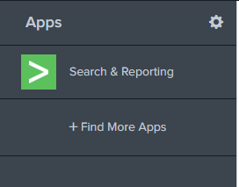

The explore Splunk section has quick links to add data, add new apps or access the Splunk documentation.

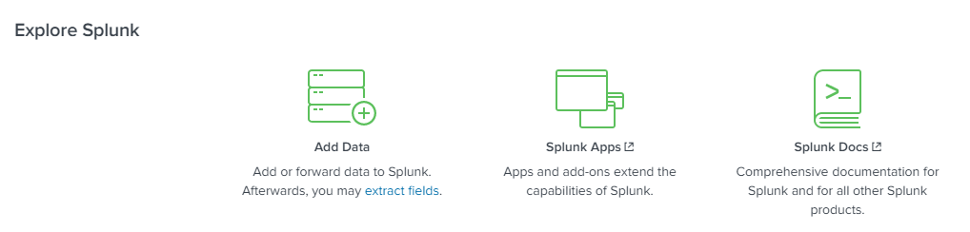

The Splunk dashboards are created by the user as by default there are none. The dashboards allow for a visual representation of data or events. Splunk can receive any type of data such as event logs, website logs or firewall logs and the sources of data are grouped into categories.

For this practical part of the lab, the focus is on VPN logs. There is a 5-step process to add data as shown below.

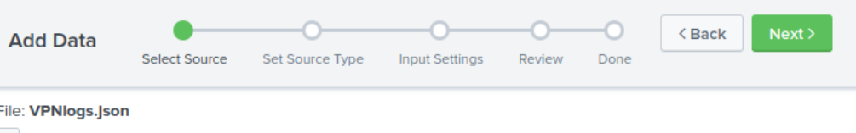

I created a new index named VPN_Logs and kept the source type as JSON.

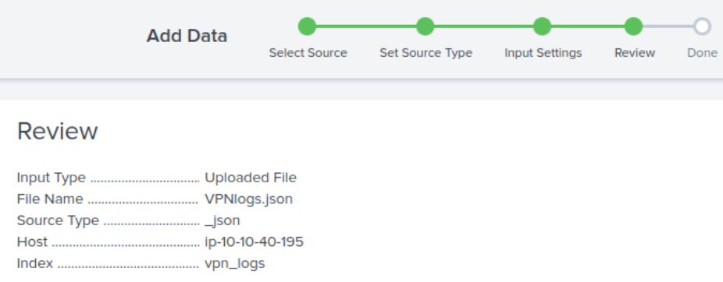

Once that was successfully uploaded, I navigated to search and reporting and set the time to all time. My first search was to see how many events there were, I returned 2862.

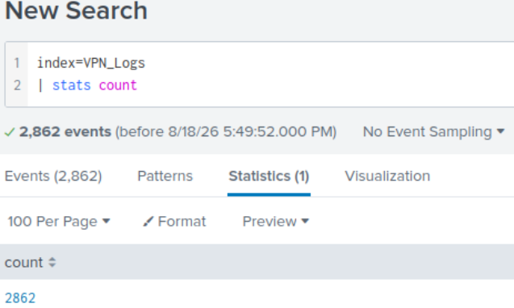

Next, I done a search to see how many events included a user by the name of Maleena which was 60.

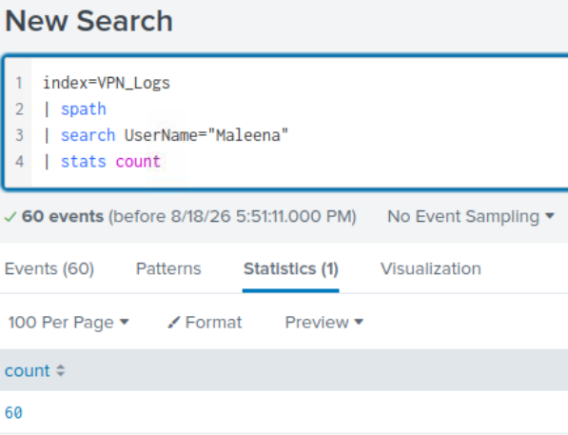

The username associated to an identified source IP was Smith

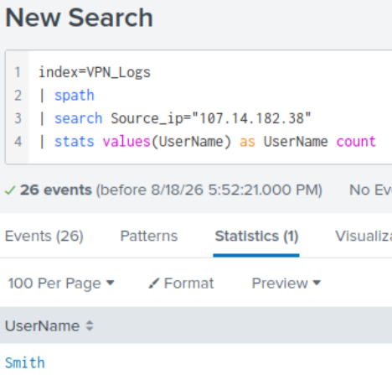

There were 14 VPN events associated with the IP address 107.3.206.58

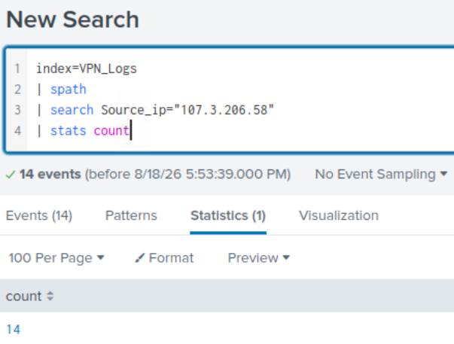

Finally, there were 2814 events that originated from all countries except France

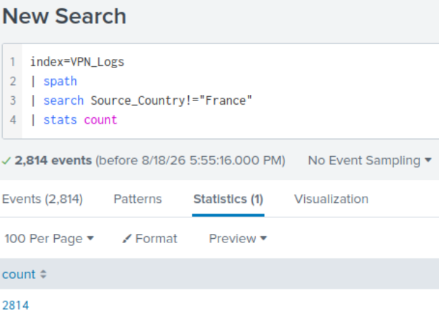

3. What I’ve learned

- Splunk components
- How to add data to Splunk
- Some SPL commands
- The different sections of Splunk

